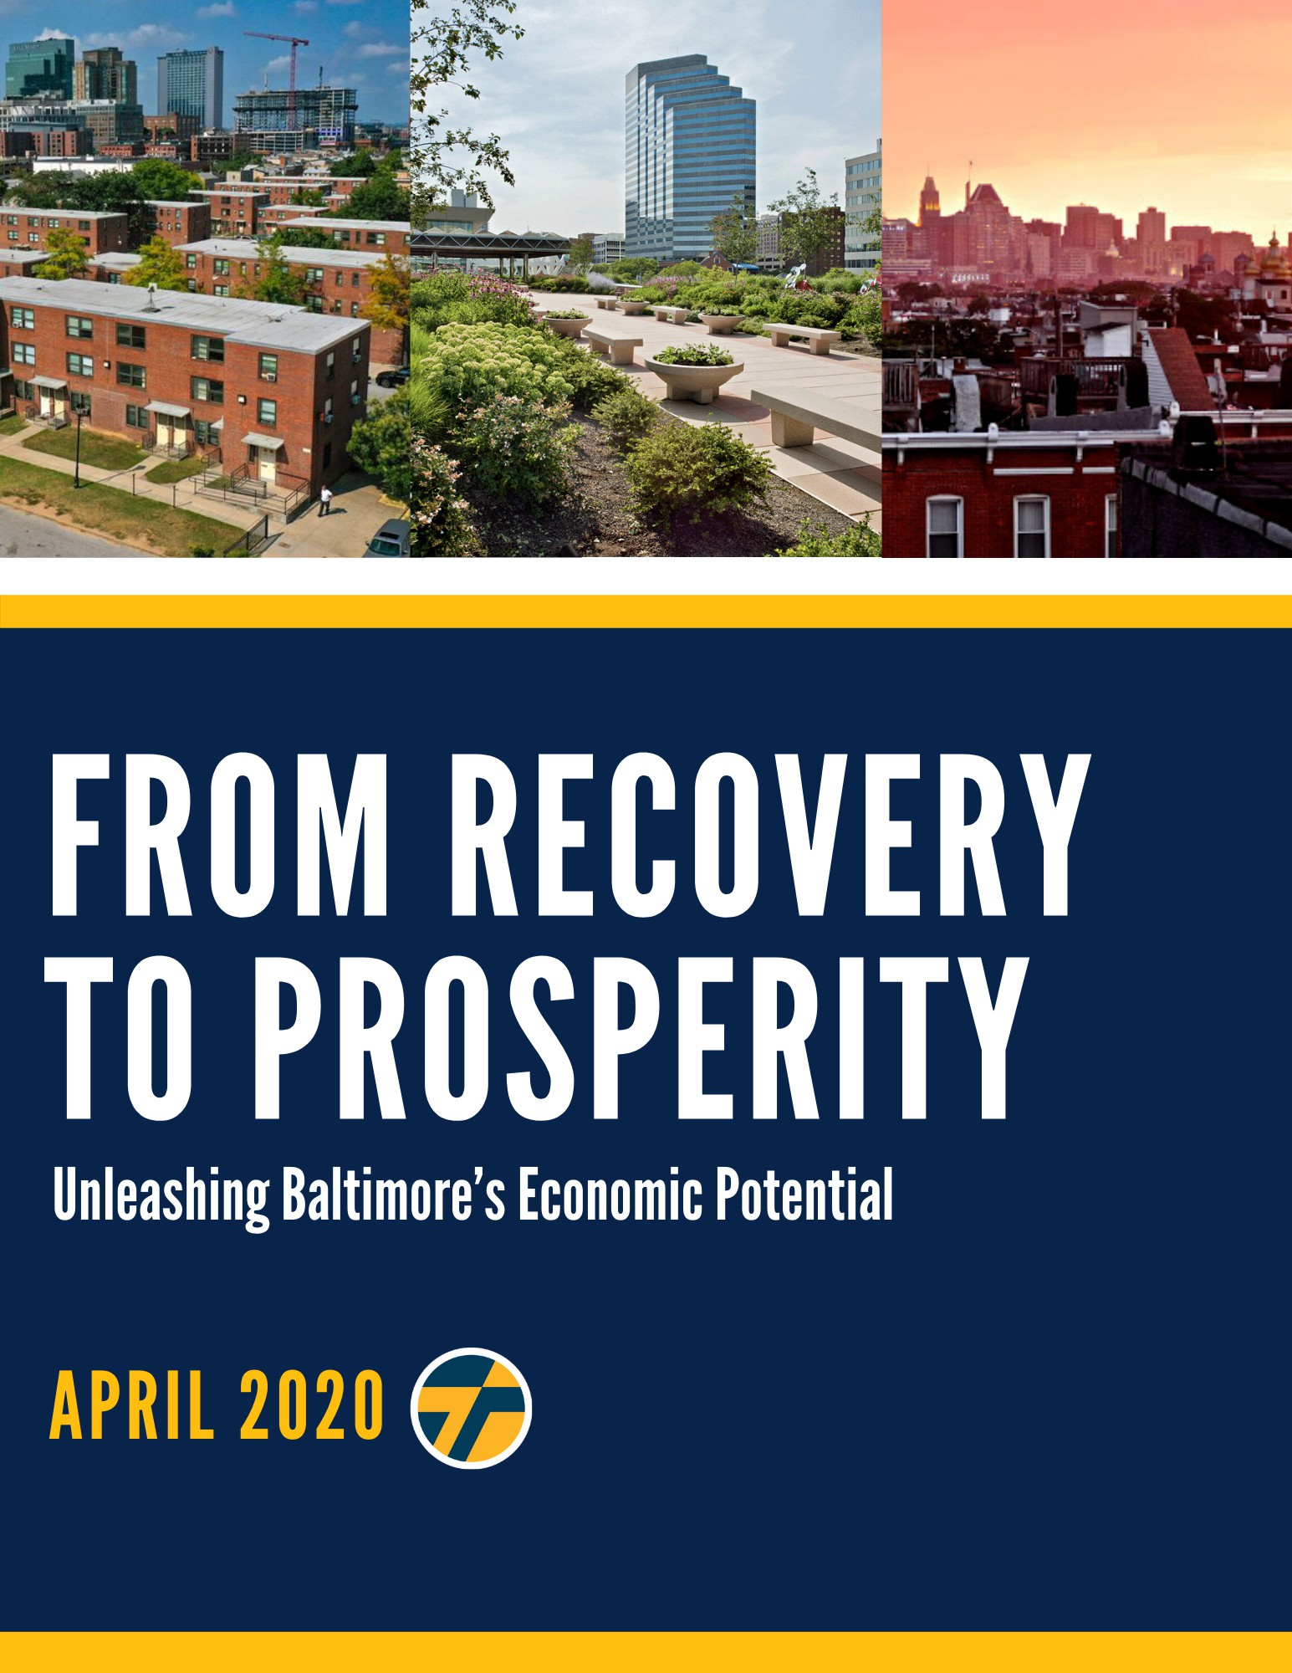

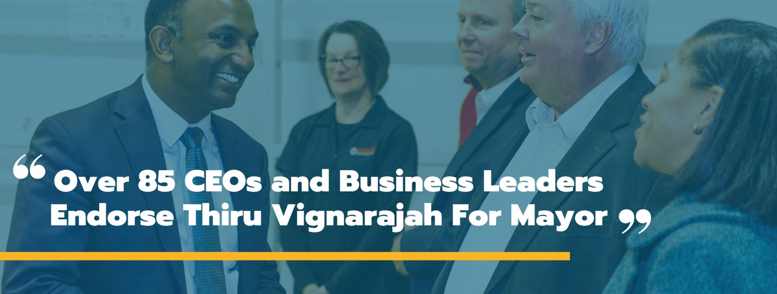

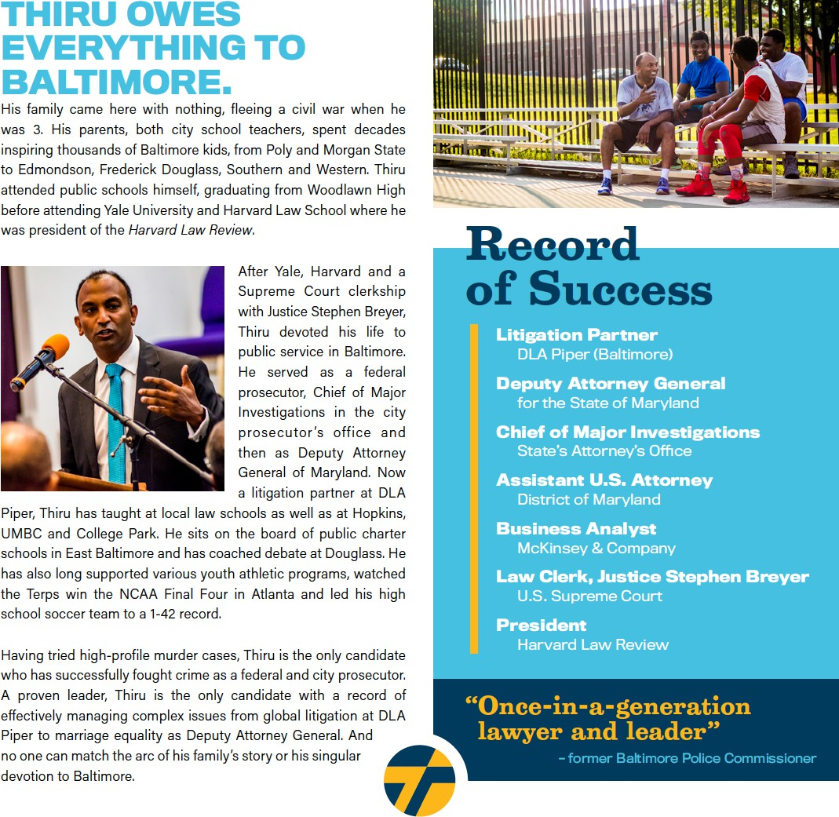



###### EXECUTIVE SUMMARY

The global pandemic presents a once-in-a-century challenge to our city, the country, and the world. It also offers a rare opportunity to rebuild, reinvest, and reimagine the economy and infrastructure of Baltimore for the 21st century.

Like disaster relief in the immediate wake of a hurricane, our plan for economic development will require innovative, short-term investments that address the acute needs of individuals and small businesses. As we head toward recovery, our strategy must also account for the substantial impact and unique difficulties caused by the closing of schools and a statewide stay-at-home order. Finally, a visionary blueprint must aim to rebuild Baltimore with innovative strategies and propel it into the future as we reimagine our local economy around industries of the future.

“From Recovery to Prosperity” is a three-phase roadmap across the relief, recovery, and rebuilding phases. Just as we rebuilt parts of Baltimore after the Great Fire a century ago, we have to address immediate needs over the next several months, seize opportunities for recovery in the following six- to 18-month period, and lay the groundwork for a five- and 10-year plan to reimagine a prosperous and inclusive economy.

This plan goes well beyond the limited proposals of other candidates who underestimate the challenges facing Baltimore and have proposed narrow solutions, limited largely to tapping into anticipated federal funding and dipping modestly into the city’s financial reserves. At a different time in a different city, that may be satisfactory to some. But, in this city at this moment of profound crisis and opportunity, the people of Baltimore need and deserve much more. This roadmap begins to chart out an ambitious course from where we are to where Baltimore could be.

Immediate: Provide Relief to Support Individuals, Families, and Small Businesses

* Inject $250 million immediately into the local economy, by drawing down Baltimore’s “Rainy Day Fund” and borrowing against our AA bond rating
* Issue municipal bonds to build digital infrastructure, including fiber optics to ensure free, universal high-speed connectivity to bridge the digital divide, prioritizing students requiring educational access
* Accelerate road repair and construction projects at lower costs and less inconvenience to the public during a prolonged period of limited usage of city streets and bridges
* Complete installations of heat and air conditioning in public schools with inadequate systems while students, teachers, and staff are absent from these facilities for no less than five months
* Stabilize the finances of first responders by guaranteeing appropriate overtime and hazard pay and by offering free local housing to avoid putting family members of essential workers at risk
* Support mid-sized non-profits overlooked by federal stimulus and minimize burden on small businesses by waiving bills on minor privilege fees and extending deadlines on business invoices due to Baltimore City
* Ensure adequate sick leave compensation to prevent essential workers from becoming vectors

Six to 18 Months: Build the Road to Recovery as We Reopen Our Economy

* Commence schedule to cut property taxes in half over 10 years in equal incremental reductions
* Stimulate development of promising growth industries that would become anchors of Baltimore’s economy for the next century, including: biotech, cybersecurity, small businesses, arts & music, cannabis, culinary arts, cancer research, driverless vehicles, port logistics, and tourism & hospitality
* Raise property taxes on abandoned properties to ensure that real estate speculators are induced to promptly begin development or sell property holdings to investors who will
* Cut vacant housing stock by using eminent domain to seize property with excessive code violations and unpaid taxes and transfer it to affordable housing organizations
* Relaunch dollar-homes program with modified city subsidies to banks, reinvest in community land trusts to expand long-term affordable housing, and effectively safeguard tenants’ rights
* Launch Office of Strategic Partnerships (OSP) to coordinate investments across philanthropic, business, government, and nonprofit sectors
* Jumpstart inclusive workforce development programs by aligning the priorities of public education, trade schools and community colleges as well as diversion, prison workforce and reentry programs with personnel needs of existing and emerging industries

Five to 10 Years: Spark for Baltimore City a Next Generation New Deal

* + Launch $3-4 billion investment in infrastructure overhaul over the next decade, pledging to match federal stimulus funds with public-private city investments for five major commitments:
  + Major public transit initiatives to potentially include East-West light rail, revitalized trolley cars, Inner Harbor footbridge, above-ground circular shuttle train, and high-speed rail to DC
  + Rebuild green network of roads and bridges currently at risk of collapsing with dedicated thoroughfares for public transit; combined with bike lanes and completion of 35-mile Gwynn Falls and Herring Run trail loop
  + Bring water and sewage systems into compliance with federal consent decree, accounting for accelerated timetable for acute weather events precipitated by climate change
  + New school construction and renovations and repairs of all existing facilities, which are currently twice as old on average as schools across the rest of Maryland
  + Smart city investments including fiber optic cable, traffic and transportation analytics, a distributed network of weather and environmental monitoring systems, and automated performance tracking of municipal services

###### Letter of Hope

Baltimore’s financial health has been at risk for a generation. A confluence of factors – the absence of audits, the presence of red tape, exorbitant property taxes, soaring crime, and no accountability – have all contributed to the economic decay of an once bustling, vibrant American city. This reality has only intensified as COVID-19 has closed businesses, produced widespread unemployment, and heightened uncertainty across numerous sectors and industries. People in Baltimore are scared and they are suffering, many of whom have borne the brunt of disinvestment decade after decade.

The next mayor will need to fight a two-front war: one against entrenched economic inequities emboldened by a global pandemic, and another against the relentless violent crime that stunts our city’s capacity to reach its fullest potential. I am prepared for precisely that.

For some, COVID-19 has temporarily exposed the pain many feel in our city each day: not feeling safe to leave home or go to work or school, or not being able to provide for one's family. With protective measures like social distancing, expanded testing, and an eventual vaccine, we will get through this public health crisis. In the same breath, we will still have to contend with the economic shock left in its wake. We need a plan that will not only answer the immediate economic harm of COVID-19, but will also target the structural issues that perpetuate crime, inequality, and lack of opportunity.

*From Recovery to Prosperity: Unleashing Baltimore’s Economic Potential* features twenty (20) major tenets – some focused on the short-term and medium-term, and others focused on fundamentally reimagining Baltimore’s local economy.

Our plan for inclusive economic growth recognizes the urgency of this crisis, but offers a vision for how we can put to work some of our city’s greatest strengths and assets.

Baltimore’s full promise is waiting to be unleashed. There is no question the road ahead will prove difficult, but together, we can set the groundwork for a future of prosperity, for all residents, no matter their zip code.

Sincerely,

*Thiru Vignarajah*

Immediate: Provide Relief to Support Individuals, Families, and Small Businesses

There is no question that COVID-19 will have a profound economic impact on the city of Baltimore. In early April 2020, the Board of Estimates outlined a $68.7M projected loss of revenue for the year as a result of the pandemic, in addition to an anticipated $100M hit for fiscal year 2021. Given unparalleled uncertainty, we’ll likely see that estimate increase. While a portion of relief is on the way via the federal government's $2 trillion stimulus package, which issues hundreds of millions of dollars for cities like Baltimore, we cannot sit idly by.

Extraordinary challenges demand extraordinary solutions. We must do something affirmative and bold. Thiru would pursue the following seven initiatives in response to COVID-19, bridging recovery efforts to an inclusive, overarching economic vision for Baltimore.

1. Inject $250 million immediately into the local economy by drawing down Baltimore’s “Rainy Day Fund” and borrowing against our AA bond rating

Baltimore already predicts a $42.3 million deficit in the budget due to reduced revenues from changes to our behavior and projected reductions in hotel and income taxes. In response, City Hall instructed all City agencies to reduce spending by 5%. This response focuses exclusively on budget constraints and fails to recognize the services needed to aid residents and businesses in this fight and the ensuing recovery. We need fiscal common sense that both prioritizes the immediate needs of our city and investments in our future, accounting for Baltimore’s situation on the cusp of an exponential growth trajectory. Thiru has proposed a massive $250 million stimulus injection to promote spending and investment, and to support our most vulnerable individuals and communities.

The purpose of the Budget Stabilization Reserve, also called the “rainy day fund,” is to provide a fiscal contingency plan that eases the effects of downturns. COVID-19 has triggered a dramatic downturn in our city that requires City Hall to support our community using the funds put aside for a moment exactly like this.

We have advocated for comprehensive financial audits to identify and subsequently address wasteful spending across City agencies. Correcting that inefficiency will more than offset the funds used from the Budget Stabilization Reserve so that we can expand and enhance needed critical care and services for vulnerable populations.

Baltimore City boasts a stellar Aa2 and AA credit rating from Moody’s and Standard & Poor. Despite the strong full faith and credit of our City, we take a conservative approach to debt issuances and, therefore, make minor investments in infrastructure that serve as a band aid on a crumbling system. In this time of unprecedented need, it is critical that we tackle the gaping holes in our infrastructure and provide assistance and services to communities hit hardest by the crisis by using funds borrowed against our bond rating.

We propose immediately withdrawing $50 million from our rainy day fund and borrowing $200 million against our AA bond rating to (1) follow the lead of San Francisco and expand sick-leave payments, specifically for high-risk essential workers, (2) support small businesses by streamlining and temporarily waiving minor privilege fees and help locally-owned restaurants and hotels by extending the deadline for business invoices related to food and beverage taxes and hotel/motel taxes, (3) offer low-interest loans to small businesses in underserved areas and delay loan repayment, (4) ensure universal internet access, (5) accelerate road repair and construction projects, (6) install H-VAC systems and energy efficiency upgrades in all city schools, (7) launch a public and philanthropic donation fund to support first responders and their families, and (8) extend assistance to people experiencing homelessness in partnership with non-profit organizations.

1. Issue municipal bonds to build digital infrastructure, including fiber optics to ensure free, universal high-speed connectivity to bridge the digital divide, prioritizing students requiring educational access

In response to COVID-19, Governor Hogan made the unprecedented decision of closing schools indefinitely. Baltimore’s students, who for a variety of reasons often fall behind state averages of achievement, are disproportionately affected by this deficit of instructional time. Even without a clear end to social distancing in sight, it is imperative that we find ways to keep students engaged in their studies. Many jurisdictions, even our neighboring counties, have decided to turn to virtual instruction. However, Baltimore City faces a “digital divide” that leaves low-income communities and, disproportionately, communities of color without internet access or access to electronic devices conducive to learning. In 2018, the National Digital Inclusion Alliance ranked Baltimore the 60th worst- connected city in America, in a study of households without any broadband internet. It found that 21.96% of Baltimore households, or 52,084 families, lacked broadband internet access of any kind.

To bridge this divide and ensure equal access to online learning, we will designate funding to pay for the purchase and distribution of laptops and internet access to families. The city should also partner

with philanthropic and community organizations to set up a fund for lightly-used laptops that can be refurbished and distributed to families in need. The Digital Harbor Foundation, for example, recently partnered with the Baltimore Robotics Program to provide free community Wi-Fi in southwest Baltimore. City Hall should fund initiatives like theirs while propelling them to a larger, citywide scale.

City Hall should also partner with broadband internet providers to offer free or significantly reduced- priced essential services to low-income households without access.

Thiru will ensure universal internet access across the city to not only educate our children in this time of virtual learning, but also ensure that adults have the resources to apply for jobs and play their bills in an era of unprecedented economic uncertainty.

1. Accelerate road repair and construction projects at lower costs and less inconvenience to the public during a prolonged period of limited usage of city streets and bridges

Given the reduced road traffic stemming from Governor Hogan’s stay at home order, City Hall has an opportunity to address top-level issues in our transit system: filling potholes, moving forward with traffic light synchronization, and conducting road repairs. While we have released our broader transit plan of substantial, longer-term investments to build an equitable and green transit grid, there is immediate work to be done. City Hall should use borrowed funds to bolster the Department of Transportation’s efforts and hire locally.

CleanStat is one of CitiStat’s initiatives to track the progress of the Department of Public Works, the Department of Transportation, the Code Enforcement team from the Department of Housing, and Bmore Beautiful. The site has been collecting data on the headway made as a part of Mayor Young’s 50-Day Pothole Challenge, which was launched on February 12, 2020. The program set a goal to fill 5,000 potholes in 50 days; but as of March 10, 2020, CleanStat has uploaded no further data on the project’s completion. City residents are still owed action, as promised, to fill the potholes. With less road traffic now than ever before, prioritizing pothole filling is common sense.

For years, Baltimore’s commuters have lamented the frustrating congestion caused by non- synchronized traffic lights. The city has 1,300 city traffic signals, roughly three-quarters of which are designed to operate under one cohesive system, where timers are purposed to prevent constant red lights and speeding drivers. However, only half of those 974 signals were operating as designed under the timer system in 2017, resulting in clogged streets, an influx of run red lights, and more accidents.

City Hall should invest in a timing-optimization program and Intelligent Transportation System technology (ITS) to coordinate the signals of all 1,300 lights, minimizing traffic congestion and promoting safety.

1. Complete installations of heat and air conditioning in public schools with inadequate systems while students, teachers, and staff are absent from these facilities for no less than 5 months

We hear our kids tell us how difficult it is to focus when they are sweating or shivering in classrooms. Year after year, we see identical headlines lamenting students sent home early when the weather turns especially hot or cold. A Johns Hopkins Study concluded that school closings due to inadequate facilities have resulted in 1.5 million educational hours collectively lost. In city schools with the largest achievement gaps, which often have student populations with disproportionate amounts of students of color and low-income students, this lost classroom time is even more detrimental. One Harvard study was able to determine that the difference in exam performance on a 90 degree day compared to a 72 degree day results is equivalent to a quarter of the Black-White student achievement gap.

With students out of schools due to COVID-19, the city has a rare opportunity to conduct repairs on aging buildings that are too-often without air conditioning in the summer and heating in the winter. With proper social distancing measures and safety precautions, we urge City Hall to hire locally to install critically needed H-VAC systems into the forty-seven schools lacking them.

Map of Baltimore City Schools Without Air Conditioning

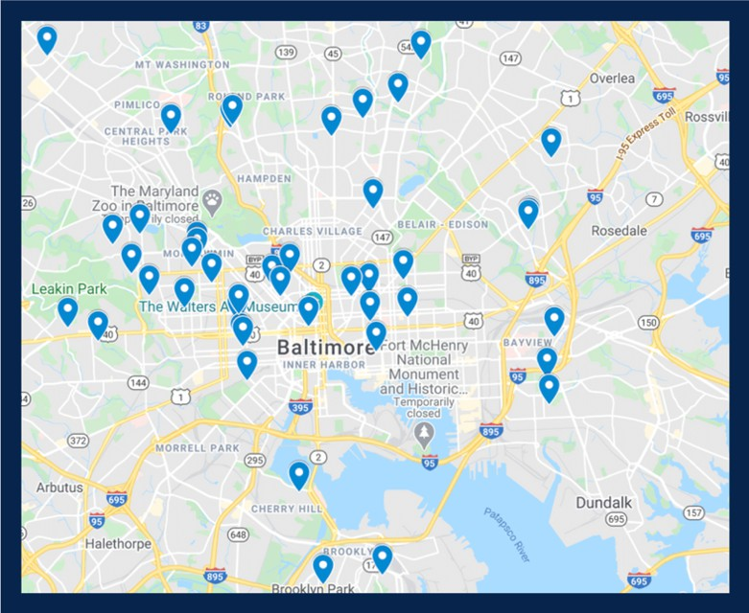

Source: [https://www.baltimorecityschools.org/ac](http://www.baltimorecityschools.org/ac)

1. Stabilize first responders by guaranteeing appropriate overtime and hazard pay and by offering free local housing to avoid putting family members of essential workers at risk

We are forever indebted to the brave first responders putting themselves on the front lines of COVID- 19 to save lives and flatten the curve. City Hall will collect donations from both the public and philanthropic partners to establish a fund supporting these first responders and their families. Relief efforts paid for through these donations will be focused on alternative housing for self-isolation, hazard pay, and a catchall fund for necessities such as groceries.

1. Support mid-sized non-profits overlooked by federal stimulus and minimize burden on small businesses by waiving bills on minor privilege fees and extending deadlines on business invoices due to Baltimore City

Small businesses and startups serve a fundamental role in our economy, and they have suffered severe damage from the crisis. Eventually, will be safe for entrepreneurs and their employees to return to work. But the city has to do everything in its power to help keep small businesses afloat until public health leaders inform us that it is safe to return to life as normal.

At a regulatory level, the city can provide temporary relief for small businesses in the immediate crosshairs of coronavirus. The city could also provide a backstop for small businesses by halting commercial evictions for the duration of the crisis; and both streamlining and temporarily waiving minor privilege fees. Baltimore could help locally-owned restaurants and hotels by extending the deadline for business invoices related to food and beverage taxes and hotel/motel taxes.

In collaboration with state partners and leadership, Thiru will work to impose a temporary sales tax holiday and delay business tax payments for restaurants, hotels and motels, and other small businesses.

Also, non-profits working to serve Baltimore, particularly during COVID-19, are struggling. The Y in Central Maryland, an employer of more than 500 people, was considered too big to receive federal relief in initial stimulus. The organization has admirably stepped up for the community, but it has been left behind with a major loss of revenue. This gap is one the City should fill.

1. Provide sick leave payments for high-risk essential workers

The Maryland Department of Labor has suggested that essential individuals who have not been quarantined but feel ill should use employer-paid time off. For a myriad of reasons, that time off may have already been used up, and – regardless – employers cap the amount of paid sick leave allotted. For many families, this limit means an impossible choice between putting food on the table and paying the bills or risking getting others or their family members sick.

Cities like San Francisco have realized the importance of sick leave in fighting this crisis – especially for high-risk essential workers who might not have enough leave to meet an appropriate recovery period. For those who are determined to be high-risk, or who are living with someone who is high-risk, we will leverage municipal funding to allocate funding to cover additional sick leave payments to match those originally determined by the employer. These additional sick days will remain until the stay-at-home order is lifted.

Six to 18 Months: Build the Road to Recovery as We Reopen Our Economy

Baltimore must act quickly to respond to the immediate and severe consequences of the virus, but it cannot lose sight of a brighter future on the horizon. When it is safe to begin reopening our streets and businesses, Thiru will jumpstart a vibrant, inclusive economy by beginning to cut property taxes, invigorating key industries, increasing businesses’ access to capital, ensuring affordable housing, and developing creative partnerships to invest in our city’s diverse and rapidly-evolving workforce.

1. Commence schedule to cut property taxes in half over ten years in equal incremental reductions

There is no better barometer of the health of a city than its population growth and decline – and people are leaving Baltimore in droves. This year, Baltimore was confirmed to have a smaller population in 2020 than it had in 1920.

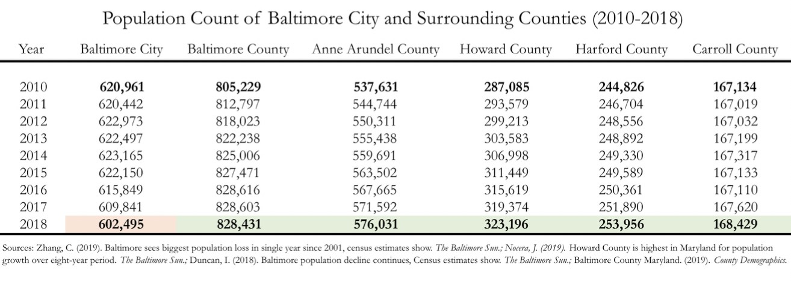

For too long, city residents have paid twice as much in property taxes as everyone else in Maryland, which naturally deflates property values, discourages investment, and induces families and businesses to leave the city. With soaring crime and broken schools, this tax rate has become harder and harder to explain. It’s no wonder more and more residents and businesses are leaving Baltimore City for neighboring counties every year. Some 7,346 residents — over a percent of our population — left last year alone. And as the population has declined in Baltimore City over the past decade, the population in every surrounding county has grown.

To be sure, property taxes drive 32.7% of Baltimore’s FY 2020 $2.9 billion operating budget. As a result, Baltimore cannot precipitously slash its tax rate without borrowing from the state or federal government or without significant reductions in services, neither of which is prudent or palatable.

But this trend should not paralyze us. While taxes cannot be realistically cut in half overnight, they can be gradually and responsibly reduced to county levels with a clear and disciplined plan. Thiru’s proposal explains the mechanics of how it will be done, what revenue reductions will mean, how the city should prepare for these cuts, and what compensatory actions the city will take.

* + *Reduce the property tax rate by .01 every year for 11 years (.22 to .21 to .20 and so forth) until it plateaus at .11, achieving equilibrium with other Maryland counties.*

Baltimore will responsibly cut property taxes while improving services by reducing the property tax rate by $.11 per $100 of assessed value each year for 10 years until it is competitive with neighboring jurisdictions. Over the decade, for a $200,000 home, these reductions will save a homeowner over $12,000. Under this plan, Baltimore City will adopt this preset schedule of tax reductions. As mayor, Thiru will require budgets prepared and ratified by City Hall to adhere to this schedule and will fix this schedule in a charter amendment.

Even without greater discipline in agency budgets, there are several reasons why city revenue is projected to grow as property taxes are lowered.

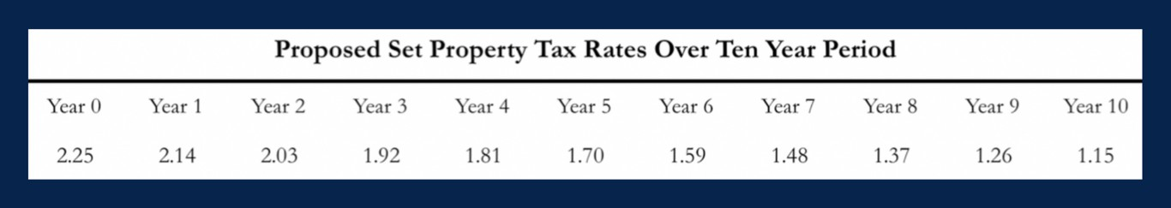

First, as cities like Boston and San Francisco have seen, pinning property tax rates can halt population flight and catalyze growth, which will generate both more property and income tax revenue in Baltimore. This is because new home purchases are based on price points determined by homeowners’ maximum monthly payment. For example, a family willing to purchase a home at $500,000 at a property tax rate of 2.2% will pay the same in property taxes ($11,000) as a family that purchased a home at $550,000 with a tax rate of 2.0% ($11,000).

* + *Crack down on fraud and require agencies to identify 1.5% annually in wasteful spending.*

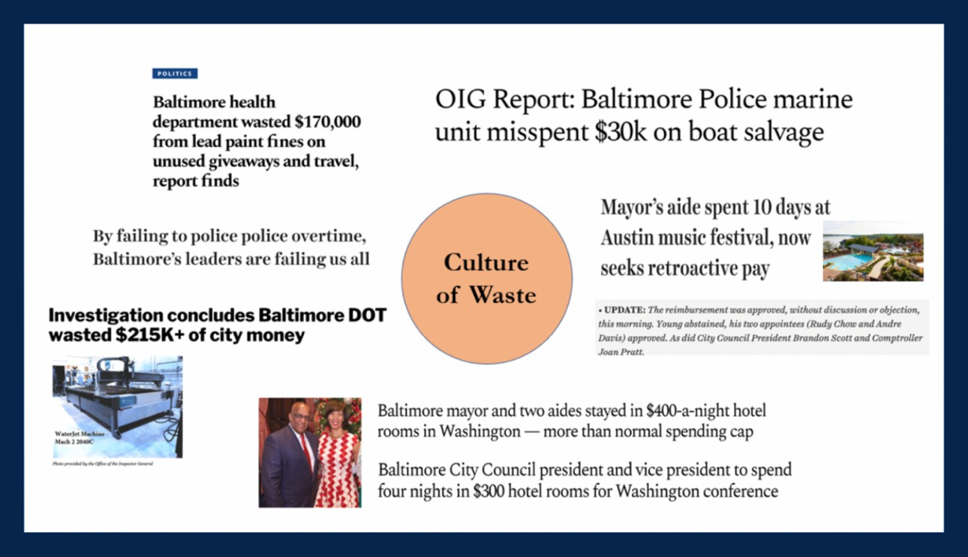

This tax cut will be complemented by required waste reduction initiatives across all city agencies. Because property taxes account for some 36% of the City’s budget, proposed cuts will reduce revenues by as much as 1.8%. In response, agencies will cut $40 million in waste and fraud, each identifying 1.5% annually in wasteful spending based on annual, top-to-bottom independent audits of City Hall. Thiru will direct agency heads to crack down on waste, inefficiency, and fraud while preparing disciplined budgets consistent with the schedule of tax rate decreases. Unjustifiably high taxes are particularly offensive when taxpayers see consistent examples of misspent funds and fraud going unchecked.

* + *Raise taxes and penalties on absentee real estate speculators on vacant, unused properties.*

Even as Thiru reduces property taxes for property in active commercial and residential use, his plan will increase code violation penalties and property taxes on vacant properties being held at virtually no cost by property speculators, many of whom are not even based in Baltimore or Maryland. This kind of strategy has generated millions in revenue for cities like Washington, D.C., which raised the commercial property tax rate for vacant property from $1.65 to $5 for

$100 in assessed value and to $10 per $100 of assessed value for blighted property. The prospect of increased taxes will either prompt development, raising the property value and thereby generate additional revenue; or the sale of the property to an owner prepared to make active use of the land.

* + *Pursue legal action to seize property from absentee slumlords and speculators on vacant and abandoned properties with unpaid taxes and persistent code violations. Tax increases and legal action will not be directed at property in residential or commercial use.*

Baltimore loses significant potential tax revenue each year because of “hypervacancy” — a term referring to neighborhoods where vacant buildings comprise more than 20% of that area’s housing stock. The level of hypervacancy in Baltimore increased from 7.5% of census tracts across the city in 1990 to more than 30% by 2018.

Following a model adopted by St. Petersburg, Florida, Baltimore will fight blight and generate revenue by taking ownership of vacant property with delinquent taxes or persistent code violations and sell them on auction or to affordable housing developers to further programs like Vacants to Value. In St. Petersburg, 800 vacant homes across the city owed $4 million in liens and unpaid assessments. Pursuing legal action reduced vacant homes by 75% in 4 years and generated $2.1 million in revenue. Baltimore has 17,000 vacant homes.

This plan is meant to reflect a new kind of leadership for Baltimore at a time when taxpayers are desperate for change. Lowering property taxes will not alone reverse the dual crises Baltimore faces. But alongside systemic changes – combating crime and corruption, strengthening our schools and transit grid, and addressing the inequities that define too many neighborhoods – a competitive, common-sense tax rate will create the climate Baltimore needs to attract investment, create jobs, and grow our population.

1. Stimulate development of promising growth industries that would become anchors of Baltimore’s economy for the next century, including biotech, cybersecurity, small businesses, arts & music, cannabis, culinary arts, cancer research, driverless vehicles, port logistics, and tourism & hospitality

Turnaround stories in other cities, like Pittsburgh and Detroit, involved fostering investment in targeted industries where cities hold a distinct advantage. In the aftermath of COVID-19, rapidly investing resources into fast-growing, profitable industries will be critical to jumpstarting the economic reversal Baltimore needs. Thiru plans to devote resources into building up these ten high-potential industries vital to Baltimore’s future:

1. *Biotechnology and Health Care*

Few cities in the world boast world class institutional anchors like Johns Hopkins and the National Institutes of Health. In addition to the rich tradition of research and ingenuity that defines both institutions, Baltimore also already has a blossoming entrepreneurial culture. Coupled with Centers for Medicare & Medicaid Services (CMS), the University of Maryland, and UMBC, Baltimore’s promise is limitless. To stimulate the biotech and healthcare industries in Baltimore, Thiru will lower taxes for biotech companies and invest in city-owned affordable incubator centers, located near prominent universities and research and development facilities, for biotech startups. This will include the city-subsidized expansions of AccelerateBaltimore and ETC Baltimore.

1. *Cybersecurity and Coding*

Cybersecurity is already emerging as a massively profitable strength for Baltimore. Several startups with meteoric trajectories have headquarters at Port Covington. U.S. cyber command is located at Fort Meade, just eighteen miles south of Baltimore City; and graduate programs in and around Baltimore have been educating the next generation of cybersecurity analysts and experts – creating an important talent pool for local employers. As mayor, Thiru will encourage and incentivize businesses and startups to find their home in Baltimore.

1. *Small Businesses and Entrepreneurship*

Small businesses comprise the backbone of any successful city. Especially in the wake of COVID-19, small business owners and employees need more support than ever before. To work towards rebuilding after the pandemic, Thiru pledges to introduce low-interest rainy-day loans and tax credits to owners, while organizing the philanthropic community’s resources to operations that need assistance getting back on their feet.

Small businesses will struggle with liquidity both during and after the crisis, leaving many in the unenviable position of cutting costs and reducing payroll. Though the federal government has set up targeted loans through the Small Business Administration and Federal Main Street Business Lending Program, these time-intensive resources likely may prove “too little, too late” in reaching our business owners. Baltimore City must do all it can now to protect its small business sector. In the short term, Baltimore should follow the lead of cities like Chicago, who partnered with local Community Development Finance Institutions to provide $100 million in low-interest small business loans directly targeting historically under-resourced communities.

Through partnerships and mechanisms like public entity and city government funds, City Hall can amplify and match philanthropic and private relief.

Even after the crisis, businesses may struggle to reopen their doors. On average, small businesses only have 27 days cash-on-hand – a number likely lower after the stress of COVID-

19. The city should ensure that loan repayment does not inhibit business’ ability to recover by allowing delayed repayments until the crisis has subsided. Additionally, Baltimore has a number of innovative microfinance programs to support small business growth and development; the mayor should work directly with these organizations to help promote their efforts and facilitate their ability to reach businesses in need of capital.

In order to recruit and retain more small business in Baltimore, Thiru has proposed three initiatives. First, as previously stated, he will streamline minor privilege and permitting fees that are costly and time-consuming. Second, he will pledge health insurance coverage for up to seven employees to companies that stay in Baltimore for at least 5 years. Lastly, Thiru is committed to ensuring that Baltimore’s small businesses are representative of the great diversity our city has. He has promised to provide tax incentives to LGBTQ, female, immigrant, or minority-owned small businesses.

All of these initiatives are meant to be carried out in conjunction with Thiru’s detailed plan to reduce violent crime and cut the murder rate in half. Small businesses cannot thrive in a city with 348 homicides a year. To specifically help small business owners, their employees, and consumers, Thiru has pledged to provide incentives to purchase, install, and register cloud- based security cameras and give financial assistance to small businesses interested in partnering with security firms.

1. *Arts, Film, and Music*

Baltimore’s rich history in art, film, and music has historically been an engine for growth. Baltimore has all the promise to once more become a cultural leader in the arts. As mayor, Thiru will be committed to reigniting the arts industry through several initiatives.

Thiru will expand and support the creation of additional arts and entertainment districts. Thiru recently stood with Peter Brooks, grandson of Jazz legend Cab Calloway, to protest the demolition of Calloway’s historic childhood home in the midst of the COVID-19 pandemic. He is committed to preserving the legacies of Baltimore’s many successful Black and Brown musicians and artists and building inclusive spaces for the new generation of trailblazers. As

mayor, he will extend tax-free income benefits in art districts to include a more inclusive concept of “artists” by allowing, for example, musicians, spoken word artists, and filmmakers.

From *The Wire* to *Hairspray*, Baltimore has been the stage of incredible shows and movies. Thiru will re-establish financial incentives to encourage television producers and filmmakers to set their works in the city and provide jobs for hundreds of Baltimoreans.

Thiru has also planned to lead a capital campaign to raise funds from private donors to reinforce the shaky financial foundation of the Baltimore Symphony Orchestra.

1. *Culinary Arts*

There are three reasons why culinary arts have become a critical part of Baltimore’s future. First, the food and beverage industry provides accessible opportunities to build successful careers – the industry is the highest percentage employer of ex-felons in the country, and over a fifth of restaurant workers are immigrants. Second, while there are numerous entrepreneurs in this industry who have been contributing to the cultural experience of our city for generations, Baltimore has a number of innovative restaurant owners, chefs, and industry players who are pushing the industry to new heights. Third, Baltimore’s restaurant industry attracts consumers within and beyond Baltimore who are willing to pay a premium for the quality of experiences our businesses offer. Thiru will inject capital and resources into up-and-coming culinary districts and introduce tax benefits for employers willing to hire returning citizens.

1. *Medical and Recreational Cannabis*

The marijuana marketplace in Baltimore is currently a chaotic free-for-all, contributing to record violence while depriving taxpayers of hundreds of millions of dollars. Illegal trade occurs unimpeded as police and prosecutors publicly squabble about whether to enforce current laws, even as street marijuana is increasingly laced with fentanyl and K-2. Medical cannabis is booming, but cannot be taxed and has virtually no licensees of color.

The bottom line: a billion dollars is spent on cannabis products each year, which largely ends up either in monopolized hands of untaxed licensees or violent gangs and drug organizations.

This is the worst of all worlds. Violence is unabated, avoidable overdoses persist, and drug proceeds remain locked in a violent black market. Moving the cannabis trade out of the shadows and into a well-regulated, transparent market will (1) reduce gun violence driven by

competing gangs, (2) decrease overdose death from laced marijuana, (3) mitigate the racial wealth gap, and (4) provide vital revenue to fund universal pre-K, finance repairs and upgrades at K-12 school facilities, guarantee free college in Maryland for public school graduates, and grow HBCU endowments. Baltimore City cannot afford to wait for indecisive lawmakers in Annapolis to take action while the City suffers from the failed war on drugs.

Just as Colorado and other states have issued permits and taxed the sale of cannabis despite its legal status under federal law, so too should Baltimore City issue sales permits and tax cannabis. The same people who think Baltimore City has to wait for Maryland law to change thought Colorado had to wait for federal law to change.

It’s time for Baltimore to lead, not follow.

* Issue Permits to Baltimore Businesses to Aid Communities of Color

When it comes to marijuana, the war on drugs has been a colossal failure. For decades, communities of color have disproportionately shouldered the costs of Baltimore’s enforcement policies. Now that America is realizing its mistake, the communities who were most devastated by the failed policies of the 1980s ought to be the first to benefit from this emerging market.

Permits will be preferentially issued to enterprises owned, operated, and controlled by historically-disadvantaged, local business owners of color and to those who commit to hire employees with non-violent criminal records who are seeking legitimate employment opportunities.

* Require Tax Proceeds be Spent Strictly on Public Education Programs

The emerging cannabis market would produce $250 million in annual revenue for Baltimore City. Maryland and others will inevitably legalize marijuana, but there is a first- mover advantage in this industry that the City should seize. In the past, residents have been promised funds for education from controversial ventures like casinos only to see money diluted or redirected to other priorities. This won’t happen again.

All cannabis tax proceeds will be strictly dedicated to key education programs, starting with (1) universal pre-K for every 3- and 4-year-old child, (2) repairs and improvements at K-12 facilities, (3) free college, community college, or trade school for public high

school graduates, and (4) funding to grow the endowments of HBCUs. These funds will be used only to support new programs and to supplement, not replace, current funding sources for the expansion of existing programs.

* Establish Infrastructure to Manage Complex Emerging Market

The City will establish a commission comprising community members – with the requirement that no member holds a conflict of interest – who will manage and make permitting decisions. The process and decision-making will be fully public and transparent so there are no doubts who made the decision and why.

Baltimore will create a city-operated credit union that holds the proceeds of cannabis sales, and distributes taxes to vital education programs, and eventually makes its reserve funds available for low-interest student and small business loans.

Thiru will appoint a safety board that will ensure that recreational cannabis is safe and free of dangerous additives like fentanyl and will create and communicate clear regulations about when, where, and how the product can be sold and used.

In theory, prosecutors in states like Colorado could bring charges under federal drug laws at their discretion. In practice, they never have. The premise of the proposed approach is that prosecutors in Baltimore have better things to do with their time than to go after permitted, minority-owned cannabis dispensaries based in Baltimore who hire residents desperately trying to obtain legitimate employment to turn their lives around. Issuing city permits and collecting taxes would no more make the sales legal under state law than issuing state licenses makes the sales legal under federal law. But, with ingenuity and leadership, we can still bring the marijuana trade out of the dangerous shadows—where gangs kill over turf—and create a safer market that redresses racial inequities and generates massive tax revenue at a time when Baltimore desperately needs it.

1. *Cancer Research*

Baltimore boasts world-class medical institutions and research facilities that have recently been alienated from partnerships with City Hall. Thiru will support these stakeholders to make our city a magnet for medical innovation and discovery. Thiru is committed to shaping Baltimore into the nation’s hub for groundbreaking cancer research. Under his leadership, we will partner with Johns Hopkins and the region’s many neighboring colleges and universities to find a cure.

1. *Driverless Vehicles*

Autonomous vehicles will still need years of development and millions of miles of training their neural networks with live drivers behind the wheel. The hesitation of other cities, which is already starting to dissipate, presents a tremendous opportunity for Baltimore. Particularly given the critical importance of Baltimore‘s port — which remains a destination of choice for car manufacturers in Europe and Asia – this is a chance for Baltimore to become the next century’s Detroit in terms of manufacturing and innovation. With immediate access to the vital I-70 interstate, this industry of the future is one Baltimore City should dominate.

1. *Tourism & Hospitality*

In 2017, 26.2 million people visited Baltimore, spending $5.7 billion in direct sales and generating $100 million in sales tax revenue. The tourism industry is a major employer in Baltimore, supporting over 85,500 jobs in Baltimore and its surrounding areas. However, travel restrictions due to COVID-19 have only exacerbated the strain on the industry, its workers, and their families. While we must ensure that all employees within the tourism and hospitality industries earn a living wage and have opportunities for upward mobility. Given Baltimore’s location and enormous cultural assets, there are tremendous growth opportunities to make tourism a vibrant economic engine.

Tourism thrives when Baltimore thrives – first, we need to make our city safe. Thiru pledges that his 20-point crime plan of unprecedented strategies will cut the murder rate in half. When we see real change on our streets, tourism will rise.

1. *Port Development*

Three advantages – Baltimore’s proximity to Washington D.C., its location along the I-95 and Amtrak corridor, and its large and booming port – make the city not only easily and quickly accessible, but an area marked for its potential for economic development.

Baltimore boasts the 11th largest U.S. port regarding the handling of international cargo and is the country’s 9th largest measured by value. Our port has both public and private terminals that, in 2018, imported and exported 43 million tons of cargo and is set to be the departure point for 100 cruises next year.

As mayor, Thiru will invest even more into the development and renovation of Baltimore’s port to incentivize more traffic and generate stable, well-paying jobs for Baltimoreans. First, he will ensure the reconstruction of the Howard Street Tunnel. An expansion of the freight tunnel will increase freight clearances and allow for more transport of goods from Baltimore’s port to other jurisdictions while creating hundreds of construction jobs. The federal government has already granted money for this project, and private partnerships can mitigate remaining costs.

1. Raise property taxes on abandoned properties to ensure that real estate speculators are induced to promptly begin development or sell property holdings to investors who will

Given the overwhelming evidence linking neighborhoods of concentrated disinvestment to violent crime, it is impossible to discuss the epidemic of violence in Baltimore today without accounting for our city’s history of housing segregation. A lack of affordable housing in the city often results in inherent instability for low income residents and contributes to the rise of abandoned blocks across the city. Unable to afford a safe place to live, tenants are often forced to either settle for substandard housing or become regular defendants in Baltimore’s rent courts.

This lack of stable housing affects more than just the roof over one’s head. Every house is linked to a community which provides (or deprives) a family access to good schools, quality food, and a safe environment. It is no surprise that quality stable housing is linked to longer and healthier lives. In Baltimore, this difference is visible in the variation of life expectancy across the city - with residents of Roland Park living an average of 14 years longer than those from Sandtown-Winchester.

For too long, Baltimore has focused its time and resources towards a few select areas of the city. The long-term solution rests in ensuring adequate investment across the city so that Baltimore is a united city, rather than a checkerboard of opportunity. While the city lacks the funds to directly invest in all neighborhoods, it possesses strong economic and political tools to redirect capital equitably.

With over 17,000 vacant properties, Baltimore is sitting on untapped housing potential. Several cities in California have moved to tax properties that are unoccupied for an extensive period of time. This diminishes incentives for speculators who acquire properties and hold them until their value is raised for resale or they can command a higher rent. By taxing long term vacancies, the city can push property holders to either increase recruitment efforts to find tenants, or reduce rents to more reasonable levels. Property owners who are unwilling to do this will face taxes that help the city fund initiatives to combat the known impacts of high levels of vacant housing.

1. Cut vacant housing stock by using eminent domain to seize property with excessive code violations and unpaid taxes and transfer it to affordable housing organizations

Baltimore city code permits city acquisition of abandoned property when the property is deemed a public safety threat and the owner of the property has failed to take the proper course of action to correct the problem. Despite having this authority for years, city leadership has failed to leverage their power and reclaim property from absentee landlords who have let it fall into disarray. In most of the incidences in which the city has exercised its authority - it has done so to demolish properties rather than invest in their revitalization or future development.

When done properly, the city’s ability to condemn and seize property can work to the public’s benefit. Evidence from St. Petersburg showed a near 75% reduction in vacant homes when the city began efforts to hand these properties to non-profits, who used them to construct affordable housing for residents. This effort functions to prevent abandoned housing from bringing down the value of entire blocks while also returning properties from absentee landlords to communities who could put them to good use. Thiru plans to seize abandoned homes from owners who refuse to care for them and subsequently sell these properties to community housing organizations.

1. Relaunch dollar-homes program with modified city subsidies to banks, reinvest in community land trusts to expand long-term affordable housing, and effectively safeguard tenants’ rights

*Relaunch Dollar Homes Program*

Thiru commits to finally act on the words and promises of past politicians and bring back the Dollar Homes Program. Under the program, residents can buy a vacant home from the city for only $1 if they promise to (1) commit 100k towards renovating the property and (2) live in the residence for at least 5 years. The program will be directed at supporting local living for law enforcement and first responders, teachers, and social workers.

In order for this program to succeed, Thiru will explore partnerships with local banks and lenders to ensure that those looking to buy a home through the program have access to the financial support they need in order to rehabilitate the property. City Hall will commit to purchasing insurance against the value of the home, then provide lending institutions guarantees that their investments are secure.

As necessary, the city will co-invest to cover any differential between appraised value of the home and money needed to rehabilitate it. By working with banks to secure low-interest loans, Dollar Homes can be made accessible to residents who otherwise may not be able to access home ownership.

*Invest In and Support Community Land Trusts*

Given the disparity in homeownership rates in the Baltimore area – white residents are three times more likely to own a home than black residents – City Hall needs to do more to ensure that homeownership is accessible to black and low income residents. Community Land Trusts (CLTs) are a promising means of collective ownership of land and capital. CLTs are nonprofits that buy land and maintain ownership of homes in the city, and then enter long-term, renewable leases with homeowners at affordable rates. When the homeowner sells, the family earns a portion of the increased property value as a stakeholder in the CLT, while the remainder is kept by the trust to preserve the affordability of the housing.

Examples from Boston have shown the ways in which CLTs can provide homeownership opportunities to individuals who would normally be limited to rental options. In Baltimore, the Northeast Housing Initiative has taken similar steps to build community ownership of property. However, given the amount of time and support these initiatives require, it is important that we look to their long-term value – not just their immediate payoffs. Each home that a CLT secures helps their initiative expand further, and is a guaranteed affordable home for generations to come. Every resident who owns a CLT home feels the pride and reaps the benefits of owning their own home, but also is securing their future by investing in their land trust’s equity. Given that homeownership is one of the key means of generating wealth for Americans, it is imperative that Baltimore support CLTs and other means of affordable homeownership. Thiru will partner with community organizations with the knowledge that these impacts take generations to see, but are incredibly important to strive for today.

*Guarantee Legal Assistance for Tenants Facing Rent Court*

Rental agreements are underlined by a power imbalance between renter and landlord. When facing eviction, tenants often are rushed through rent courts with little understanding of the system or their rights. Tenants rarely have representation and few know how to defend their cases in court, presenting landlords with the upper hand.

Thiru will commit to increasing public attorney resources to defend tenants facing evictions in rent court, allotting them a fighting chance at repelling invalid eviction charges. While the city would be unable to provide a personal attorney for all cases – 150,000 cases interact with rent court annually –

the city should provide a centralized access point to legal resources regarding Rent Court procedures, the status of their cases, and housing assistance services to halt eviction.

Thiru will also support adding city renter protections that prevent evictions unless the landlord could prove just cause for eviction, similar to those implemented recently in San Jose.

*Expand Eviction Prevention Policies and Post-Eviction Rehousing Services*

It is time that we stop considering homelessness a problem once the person has already lost their home. Baltimore can reduce costs associated with emergency housing and prevent tenants from needing to uproot from their communities by expanding eviction prevention policies safeguarding renters in need of short-term assistance. The HomeStart program, based in Boston, seeks to prevent tenant evictions by helping manage the cases of at-risk tenants, negotiating agreements with landlords and covering back rent payments when necessary. Landlords avoid the high costs of eviction, the city spends less on emergency housing services, and tenants can continue to stay in their homes. Thiru will launch a similar initiative in Baltimore, implementing partnerships that seek to provide tenants with guidance and low-to-no interest loans to cover rent on rainy days. By loaning small sums from the city, tenants can avoid predatory lending practices and stay out of rent courts during periods of hardship.

Not all evictions are preventable, and some extreme circumstances will still push tenants out of their homes and onto the streets. For these individuals, Thiru will shore up emergency housing shelters and expand the services that these centers provide without imposing arbitrary constraints on length of stay. Emergency housing shelters should serve as a point for residents to bounce back to stable housing, not a means of keeping them off the streets.

1. Launch Office of Strategic Partnerships (OSP) to coordinate investments across philanthropic, business, government, and nonprofit sectors

It is the duty of city government to lead effectively – with integrity and urgency – in the face of tremendous obstacles. We are in the middle of a once-in-a-century challenge that demands an alliance between business, philanthropic, and civic and nonprofit actors. To tackle the stark inequities and consequences of long-standing disinvestment in some of our most struggling communities, which is further highlighted by the devastating wake of COVID-19, we need to work together.

We are fortunate to have scores of local private and social players dedicated to creating a brighter future for Baltimore. Foundations understand that City Hall could be a partner in their push for scaled

impact and systems change. Community organizations and nonprofits have been tirelessly committed to their constituents, and would benefit from additional opportunities for collaboration and partnership. And, many private firms see social responsibility and civic engagement as essential for employee retention and community development – in other words, businesses do well by doing good.

Cities like Memphis, New York, and Asheville have proven the importance of a shared vision of progress, where cross-sector initiatives and clear metrics resulted in job creation, a more efficient city government, and drastically lower crime rates. However, because of failed leadership in City Hall, we have long gone without a coordinated strategic plan. We need to unite our best assets and key stakeholders under a comprehensive plan – across silos and barriers – to sustainably lift up individuals and communities in every neighborhood.

Thiru’s Strategic Partnership Initiative will spur equitable growth and drive the cross-sector partnerships needed to solve our city’s most challenging problems. As part of this initiative, Thiru has pledged to:

* + Create an Office for Strategic Partnerships (OSP) in City Hall to promote capital development in Baltimore through public-private partnerships and to coordinate city resources with greater efficiency and transparency. During and after the COVID-19 crisis, there should be close coordination across sectors to provide care to underserved communities.
  + Lead a Collective Impact Taskforce to convene public, private, philanthropic, and nonprofit stakeholders to more effectively and holistically address the core challenges affecting Baltimore City. In light of the COVID-19 crisis, we will divert resources to food delivery, health services, and affordable housing development.
  + Establish a City-affiliated Strategic Partnerships Fund to incentivize and support resident-driven development initiatives that bring together neighbors, small businesses, and community organizations and institutions.

1. Jumpstart inclusive workforce development programs by aligning the priorities of public education, trade schools and community colleges as well as diversion, prison workforce and reentry programs with personnel needs of existing and emerging industries

With higher unemployment rates than any other jurisdiction in the state and a much higher rate than the national average, Baltimore is in desperate need of new pipelines to success. Thiru will invest in

industries that will put our natural assets to work and create career and training opportunities for everyone from PhDs at Hopkins to individuals entering the workforce without a GED.

In order to help curb recidivism and to meet individuals returning to society from prison with an apprenticeship and a job, Thiru will scale proven programs, such as the District Court Re-Entry Project, and launch both the Court to Career Program and School to Success Initiative. He has already proposed his Court to Career (C2C) Program, which is an adult diversion initiative; along with its parallel program, School to Success (S2S), which is purposed for diverting juvenile offenders. Both programs match individuals with employment opportunities with room for advancement and growth.

In its first full year, C2C and S2S will help divert 1,000 individuals who are charged with low-level offenses from the revolving door of poverty, crime, and prison to a constructive path of job training and paid employment opportunities as a condition of receiving a probation before judgment (PBJ). This will require partnerships between district court judges and juvenile masters, probation officers, case workers, skills training programs, apprenticeships, and employers who are prepared to hire at-risk individuals and give them a second chance. Only when individuals complete the program, having demonstrated stable employment and no criminal activity, are they taken off probation with their records expunged.

For juveniles, the programs will adopt apprenticeships and work schedules that are compatible with school and other vital obligations. School to Success will prioritize programs geared to all facets of enterprise and academic achievement. Thiru will ensure expanded opportunities for vocational school instruction, university-level coursework, and internships/apprenticeships, making them more readily accessible to students completing their junior and senior years of high school.

Five to 10 Years: Spark for Baltimore City a “Next Generation New Deal”

From forging the first leg of the American railroad to mapping the stars with the Hubble Space Telescope, Baltimore’s history is defined by industry and innovation. Though our city has suffered from job erosion and disinvestment, Baltimore’s potential is tremendous. We are a city that pioneers the cutting-edge of medicine, launches next-generation businesses, and sets the standard for creativity in the arts. Our restaurants make headlines while creating community. We welcome immigrants while celebrating businesses that have thrived in Baltimore for generations. Baltimore has nearly 14,000 businesses, both big and small; and one third of our labor force – one of the highest percentages in the country – devotes their careers to service through the nonprofit sector. We are a city shaped by individuals dedicated to the promise of progress.

Thiru will offer Baltimore a New Deal for the next generation by injecting a massive stimulus investment, redesigning our transit network and water – sewage system, rebuilding our crumbling schools, and leading the nation in smart city innovations. This “Next Generation New Deal” will help unleash our city’s full promise, a promise of prosperity and equity, hope and opportunity.

1. Launch massive $3-4 billion investment in infrastructure overhaul over the next decade, pledging to match federal stimulus funds with public-private city investments for five major commitments.

As Baltimore ushers in a new era of economic development, City Hall must begin a second round of infrastructure investments. Thiru has pledged to match federal stimulus funds granted to the city by again borrowing against the city’s AA municipal bond rating, this time a sum of $3.5 billion, to invest over a five – 10-year period. This will be supplemented by leveraging philanthropic partnerships and coordinating with investors and businesses.

The funds will go towards five major initiatives: (1) the design and construction of a green transit network, (2) building a water/waste system that is in compliance with the federal consent decree, (3) launching massive renovations of city schools, (4) constructing an equitable transit grid, and (5) beginning smart city investments.

1. Major public transit initiatives to potentially include East-West light rail, revitalized trolley cars, Inner Harbor footbridge, above-ground circular shuttle train, and high-speed rail to DC

Due to necessary social distancing guidelines, Baltimore’s transit system has significantly decreased its operations by limiting lines and routes. Once the COVID-19 crisis subsides, Thiru will work with state and local transit authorities to restore Baltimore’s transit system to greater capacity than before the public health crisis, creating an equitable transit grid while also offering an array of new employment opportunities at all levels.

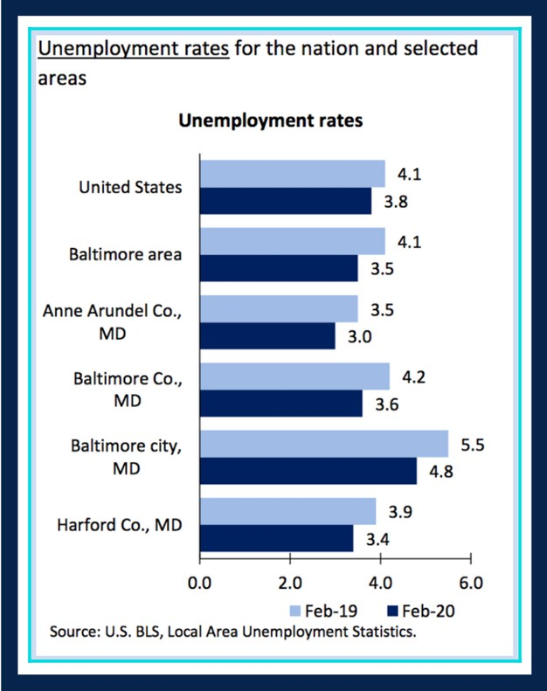Thiru will prioritize two major public works projects: expanding free circulator routes to include major west-to-east corridors and critical arteries to historically disinvested neighborhoods; and leading the charge to build the primary route of America’s first high-speed rail line, connecting Baltimore and Washington, D.C. These projects will lay the groundwork for the exploration of other transit alternatives, from a revitalized trolley car system to an above ground circulator to gondolas to a footbridge across the harbor.

The city's free transit system—the Charm City Circulator—is designed by Visit Baltimore, which is a 501c6 with municipal and corporate partners, designed specifically to market the city—not to provide widespread

public transit. We need to reform the purpose of free-fare buses to specifically target riders who lack alternative transit options. Expanding free circulator routes to East-West corridors and major arterial roadways like Pennsylvania Avenue and Harford Road will reduce pollution as ridership increases, reduce commute times, make the City more accessible, and facilitate economic development by providing realistic transportation to job centers and employers. Economic empowerment through transit is critical to Baltimore, which suffers higher unemployment rates than neighboring jurisdictions. Thiru will lobby to start construction of the proposed 14-mile East-West transit line between Baltimore County and downtown, connecting the Light Rail, Metro Subway, and MARC train and instituting a comprehensive transit grid.

Thiru will lead the fight to break ground on the first American leg of high-speed rail connecting DC and Baltimore with a 13-minute bullet train, guaranteeing substantially discounted commuter fares based on income, and induce competitive, international bidding to reduce overall project costs.

1. Rebuild green network of roads and bridges, which are currently at risk of collapsing, with dedicated thoroughfares for public transit, combined with bike lanes and completion of 35-mile Gwynn Falls and Herring Run trail loop

Thiru will execute a Complete Streets redesign that considers the racial and socioeconomic equity of our roads and bridges. This will enable safe pedestrian traffic across the city, including East-West avenues reserved exclusively for green and active transit: pedestrians, bikes, scooters, and buses.

In addition to planning designated bike lanes and green transit avenues, Thiru will fund the creation of the Gwynns Falls Trail and Herring Run Trail 35-mile trail loop will integrate transit and nature by connecting 80% of neighborhoods to greenspace and recreational trails.

1. Bring water and sewage systems into compliance with federal consent decree, accounting for accelerated timetable for acute weather events precipitated by climate change

Our water infrastructure is crumbling, in violation of federal law and posing a grave public health risk. Faulty, cracked sewer systems caused the 32,000 gallon sewage leak into Jones Falls, a waterway into the Chesapeake Bay. Pipes inundated after a big rainfall lace sewage with stormwater, entering our waterways and taking a toll on local wildlife.

1. New school construction and renovations and repairs of all existing facilities, which are currently twice as old, on average, as schools across the rest of Maryland

City public school students are substantially disadvantaged by old buildings, facilities, and equipment as well as inadequate school supplies and resources. In addition to bond-supported funds for new school construction, Thiru will commit $100 million to finance discretionary maintenance and

renovations, earmarking funds for next-century educational infrastructure (e.g., platforms for robust remote learning).

Spending on education has the highest return of any investment in public goods or services. Education spending is about investing with low-cost capital now to generate future tax revenue and savings in areas like health and criminal justice. Using available social financing tools and leveraging opportunities for impact investing, Baltimore can rebuild, revitalize, and reimagine its education system with funds from an array of private sources.

1. Smart city investments including fiber optic cable, traffic and transportation analytics, a distributed network of weather and environmental monitoring systems, and automated performance tracking of municipal services

Thiru will usher Baltimore into a new era of technology and innovation as well as introduce major structural changes to city infrastructure that use data analytics to cut waste and promote efficiency. Following the leadership of cities around the world, Thiru will begin massive data collection on traffic patterns, utility (internet, water) usage, and environmental and weather patterns to then digitally transform our systems and procedures.

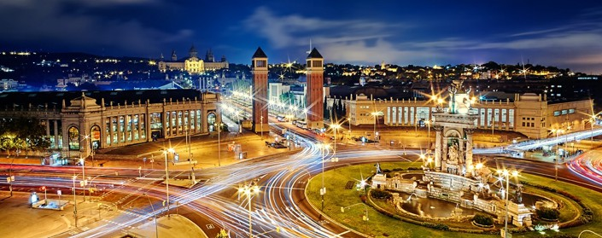Around the world, investments into digitalization and “smart” technology have been proven to save money. Barcelona reported savings of more than €75 million (over $81 million) following infrastructure investments in smart water, lighting, and parking. There is massive opportunity for local job creation and industry development, transforming Baltimore into a hub for technological innovation.

Barcelona Smart City

In the short-term, Thiru will invest in a timing-optimization program and Intelligent Transportation System technology (ITS) to coordinate the signals of Baltimore’s 1,300 traffic signals, minimizing traffic congestion and promoting safety.

Thiru also plans to develop a citywide, digitized pothole detection program. We will use sensors attached to city-owned vehicles, which naturally traverse the city, to measure width, depth, and severity of potholes; and then log that data into a publicly-available system. This monitoring serves as a measure of accountability, ensuring that the public can track and visualize the completion of 311 calls and that the most severe and significant potholes are filled first.

Baltimore’s current water billing system is inherently flawed, and notoriously issues exorbitantly high bills to residents resulting from undetected, yet often preventable, leaks. When a resident sees a high bill and calls in to complain, the Department of Public Works (DPW) examines hourly water usage; if the meter is constantly running all day and all night long, DPW naturally concludes there may be a leak, big or small, and then takes action. But there is no reason DPW should wait for residents to call-in about data DPW already has in its possession. As mayor, Thiru will implement computer monitoring of hourly meter rates to detect sudden spikes in usage or constant water flow that are symptoms of water leaks. Leaks left undetected and unattended, combined with crumbling infrastructure, have direct consequences – like Poe Homes being left without water for weeks, and recurring stories about sinkholes developing in and around our city. Catching leaks early and taking steps to fix them will reduce costs for the city, save families money, and lower the risk of catastrophic water main breaks.

Thiru will lead the effort for universal fiber optic internet infrastructure made free for public consumption. He will initiate competitive bidding among providers before laying the groundwork to ensure coverage in all neighborhoods, making Baltimore the national leader in internet accessibility.

Smart technology can be designed to serve two purposes: to reduce energy consumption and promote sustainability, and to reduce operation costs. Thiru will install LED bulbs into streetlights, which can be dimmed and brightened in accordance with data on location, weather, and time of day. City Hall will also prioritize research and data collection on air pollution and waste management in order to develop the cleanest possible policies and procedures.

###### A FINAL NOTE

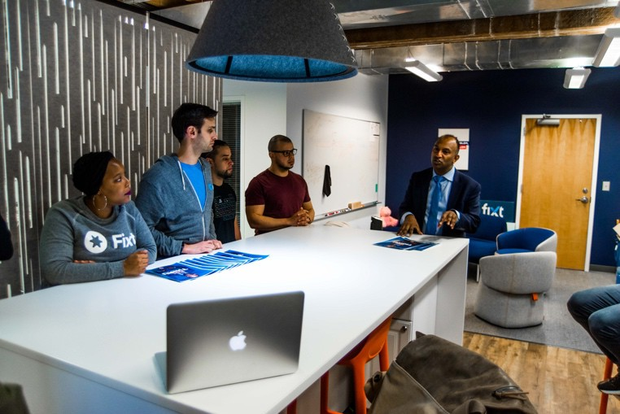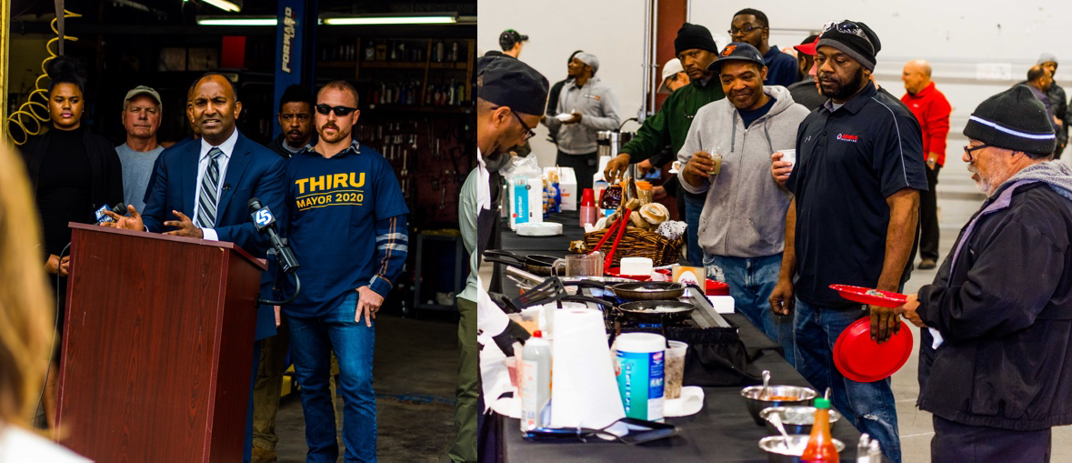

We will make Baltimore all it can be by building an economy that works for all of us – in all neighborhoods, across all walks of life. Acting on this clear, inclusive vision is exponentially more important as we enter a period of economic uncertainty resulting from the COVID-19 pandemic. Our campaign knows that low-income and minority communities are hit harder by the virus, and will face the brunt of the economic challenges it brings. Implementing long-term investments through these three-phase initiatives will directly support those most impacted by the crisis in the short-term, while ushering in a new era for Baltimore’s economy as we move to a brighter future. *The city that built the first leg of the American Railroad can once again be a nationwide leader in innovation and development. Thiru is the leader to get us there.*

